The immigration debate is complex and emotive. We must reframe it honestly

Peter Lewis
Immigration has been great for Australia but our cities are struggling to keep pace with growth. Let’s be clear about what we argue about
- Sign up to receive the latest Australian opinion pieces every weekday
Contact author
@PeterLewisEMC
Tue 24 Apr 2018 12.16 AEST Last modified on Tue 24 Apr 2018 21.38 AEST
- Share on Facebook
- Share on Twitter
- Share via Email

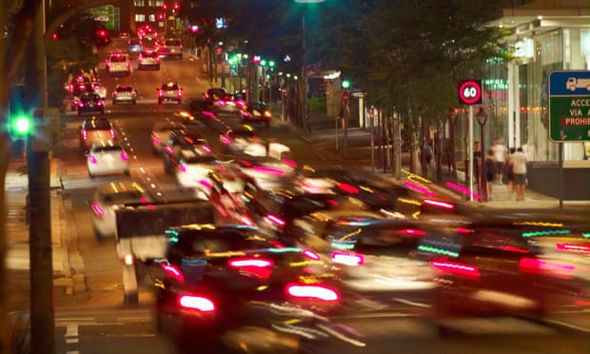
‘A mindless embrace of the economics of growth or the casting of racist aspersions against anyone who argues for lower intakes both play into conservative’s hands,’ Photograph: Alamy Stock Photo
Internecine sparring over immigration within the Coalition is merely a warm-up for what looms as potentially the biggest electoral risk to a Shorten Labor government.
The significance of the contributions of Abbott, Dutton, Morrison et al in the past fortnight is not just about Coalition policy on the appropriate annual permanent migrant intake, it is about landing on a unified story to wedge the ALP.

Australians growing more concerned over immigration – Guardian Essential poll
Read more
That the lead on the issue is coming from the presumptive candidate to roll Malcolm Turnbull if the leadership finally collapses should come as no surprise. As the minister for home affairs, immigration and border protection overseeing an extended mandate, Peter Dutton has the tools at his disposal to play the immigration card howsoever he sees fit, from crackdowns on migrant cheats to referential treatment to white South Africans.
Dutton with the active backing of a murder of rightwing commentators is raising permanent immigration as a political problem to be fixed. Our cities are overcrowded, the argument goes, migrants are a burden when they don’t assimilate quickly, look at what’s going on in Melbourne with the Sudanese, something must be done!
While the official government line as articulated by treasurer Scott Morrison remains the economic benefits of immigration outweigh the costs, the government has also been at pains to point out the annual intake of 190,000 is a target only, and the government is actively tightening access.
Sign up to receive the latest Australian opinion pieces every weekday
This opens the way for symbolic “rejections” of “unworthy” Australian citizens to drive headlines of immigration crackdown while doing nothing to alleviate the underlying problems of cities that aren’t able to keep pace with growing populations.
This is dangerous territory for Turnbull. By locking in immigration at 190,000 he is opening himself up to attack from his conservative rump as well as from One Nation on more explicitly racial grounds.
But it also provides a significant risk for Labor. If Dutton does replace Turnbull on a wind back immigration platform, Labor will find itself in a three-way wedge between a populist nativist agenda, economic growth principles and an activist/Greens movement that will call out anything perceived as anti-immigrant as a lurch to the right.
So where are the Australian public currently placed on the immigration issue? In spite of the protestations of the spirited economic defence of recent days, there is a strong majority who believe immigration levels are too high.
The significant numbers are the large increase since October 2016 and the strong consensus between voters of the two major parties. But dig a little deeper and there is a clear driver to attitudes around immigration – and that is that population is growing too fast.
It’s worth staying here for a moment. Population growth looms as a more honest and less emotive way of addressing the concerns underlying our attitudes to immigration, because all of a sudden we are focusing on the common experience of a growing population rather than individual immigrants.
For example, when we ask people what the big problems with our cities are, immigration emerges as a lower tier issue, behind the mismanagement of the property market and failure to invest in infrastructure.
Similarly, extending the debate to population allows for a broader investigation of Australia’s intake system, particularly the classes of short-term visa which dwarf the permanent immigrants by a factor of more than 10.
What emerges here is that if you chunk down our intake there are different debates to be had around different classes of population growth.
While there is scepticism with increasing intake of all classes, the outlying classifications are predictably refugees but also temporary skill shortage visas (TSS, replacing the 457 visas), which are used to plug perceived holes in the supply of local workers.

Housing report says migration may need to be cut to preserve quality of life
Read more
Student visas are integral to our burgeoning education export industry, holiday visas are integral to the tourism industry, skilled and business visas have expanded as more wealthy individuals have earmarked Australia as a home. The common thread is debates about these programs are all deliberately clouded as permanent immigration numbers become the proxy war.
A more detailed series of questions create a more nuanced starting point for an immigration debate.
Just take the top three statements as a unifying storyline – immigration has been great for Australia but our cities are struggling to keep pace with growth and we don’t like the way short-term work visas are undermining local jobs.
Strip out any race-based rhetoric, and there’s the foundation for a productive discussion about the sort of country we want to have.
Take the three lowest rating statements and you can see how a “take your immigration medicine it’s good for you” is counterproductive and probably does more harm than good.
This is a complex and emotive issue. Progressives need to be clear about what they are arguing about. A mindless embrace of the economics of growth or the casting of racist aspersions against anyone who argues for lower intakes both play into conservative’s hands.
Instead we need to reframe the immigration debate honestly, recognising the widespread concern about rising population levels due to a failure of government investment before calling out the economic short-sightedness of short-term working visas.

The changing shape of Australia's immigration policy
Read more
It goes something like this:
In attacking Australia’s permanent migration program a Dutton government is exploiting frustrations with poor government planning to tear at the fabric of our modern, open society.
Migrants invest in Australia. They commit to our joint future – they participate fully and make us stronger. Short-term visas are a transaction, and like all transactions they have a cost as well as benefits.
If we are concerned about population levels, it is these short-term economic visas that should be a focus, not our long-term commitment to permanent immigration that should continue to enjoy bipartisan support.

